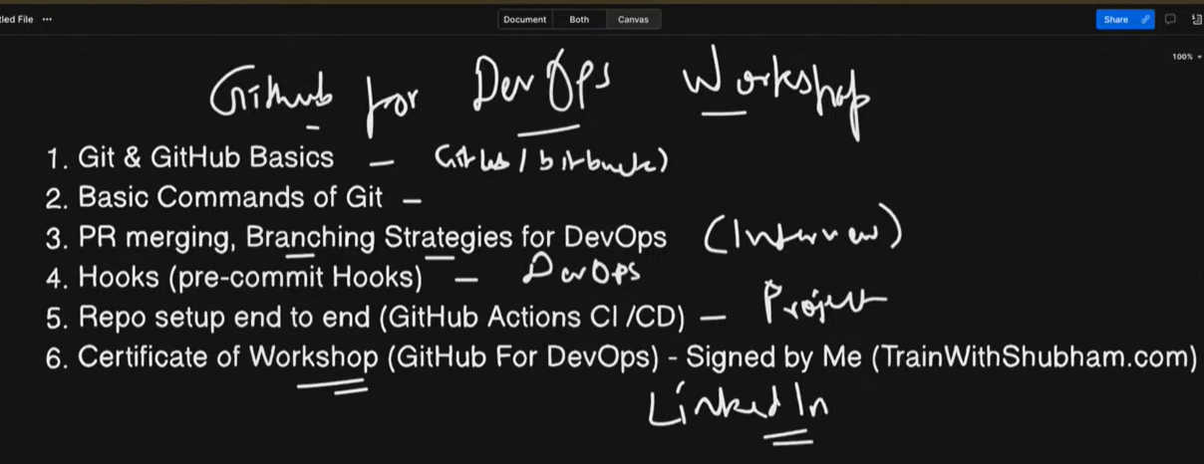

Git:
Git is Version Control System (VCS) used in industry that stores source code and record of your code.
Linus Torvalds Created Git, (Also created Linux OS)
Git --version: Check if Git install on our system with its version
